1. 
2. 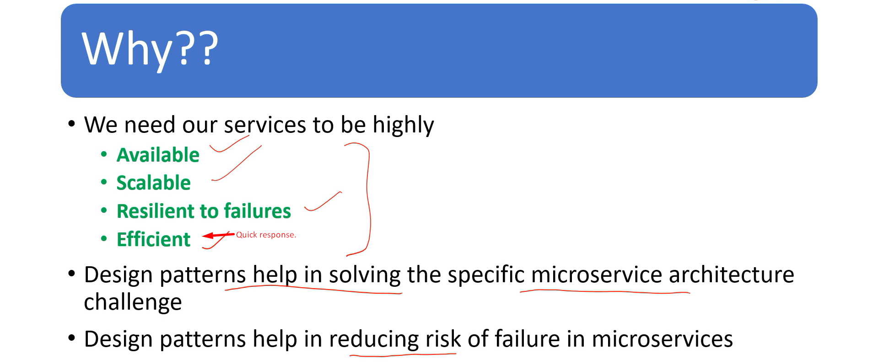
3. Skipped.